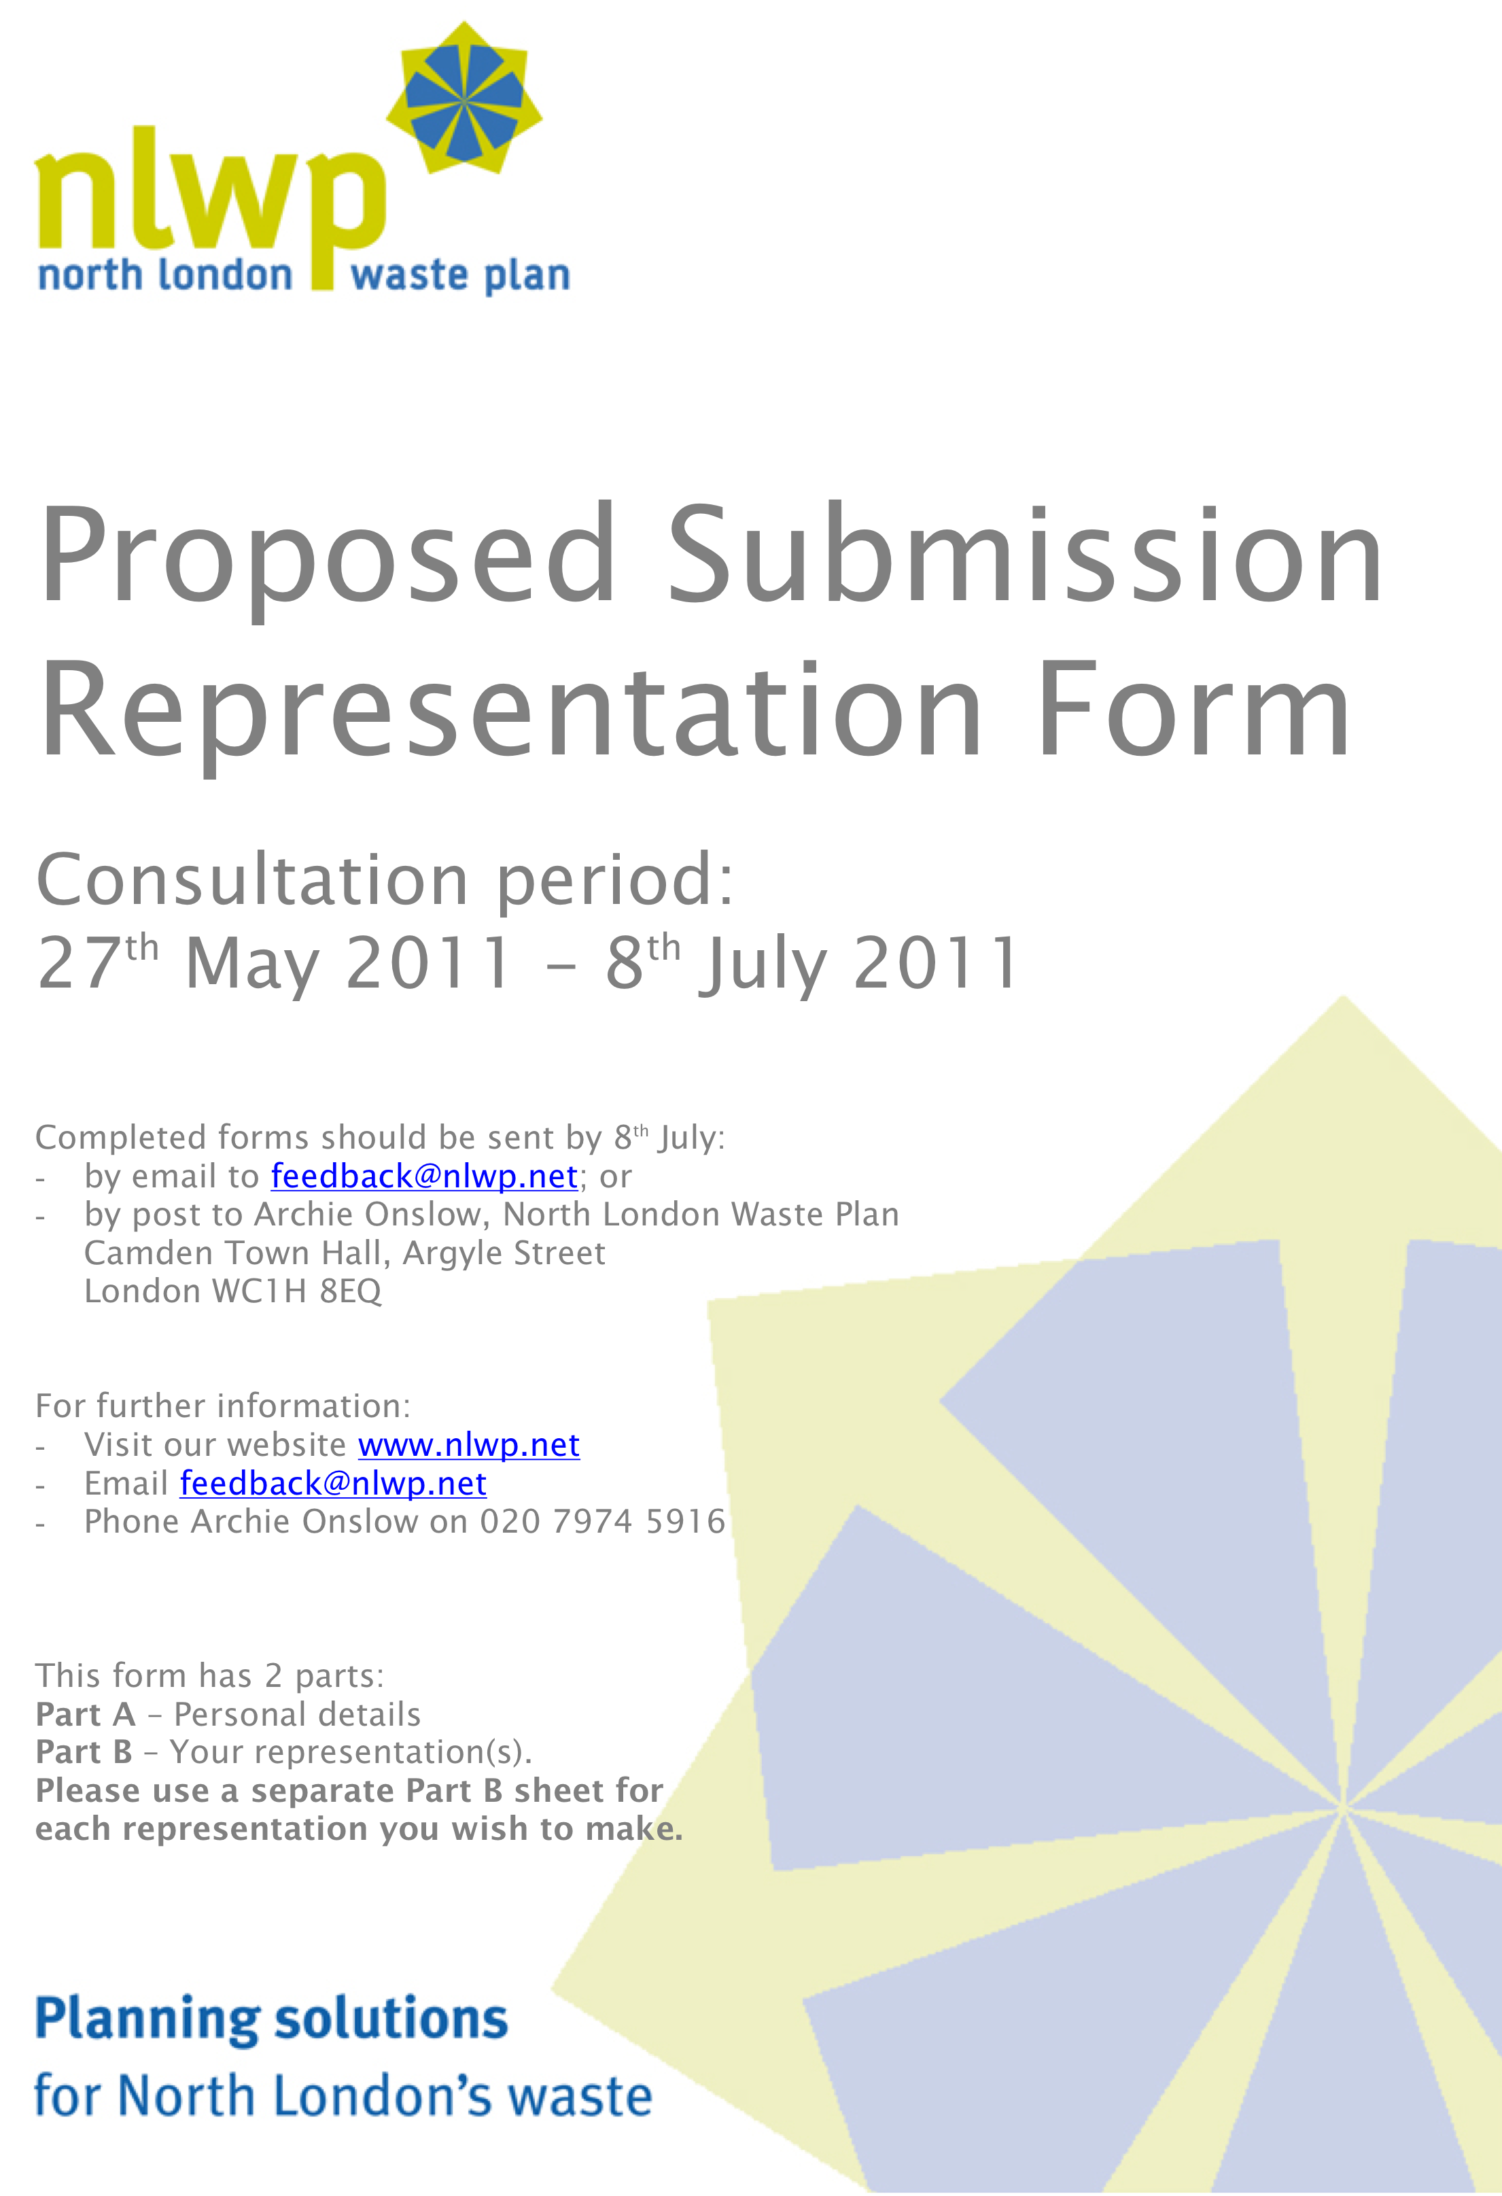

Proposed Submission Representation Form

Consultation period:
11th May 2011 – 22nd June 2011

For further information:
- Visit our website www.nlwp.net
- Email feedback@nlwp.net
- Phone Archie Onslow on 020 7974 5916

This form has 2 parts:
Part A – Personal details
Part B – Your representation(s). Please use a separate Part B sheet for each representation you wish to make.

Reference number
(For internal use only)

Please refer to the Representation Form Guidance Note before completing this form. An electronic version of this form and the guidance note are available from www.nlwp.net

Section A – Personal Information

If you are providing more than one representation you only need to fill in this section once.

 | Personal details |  | Agent’s details (if applicable)
Title:
First name:
Surname:
Job title (if relevant):
Organisation (if relevant):
Address line 1:
Address line 2:
Address line 3:
Address line 4:
Postcode:
Telephone number:
E-mail address:

Representation reference number
For internal use only

Section B – Representation information

If you wish to provide more than one representation, please complete an individual copy of Section B for each representation. You only need to fill in Section A once.

1. To which part of the document does your representation relate?
Policy Evaluation Scoring for Pinkham Way
Paragraph All of Section 3 Site Assessments
Table (please state which table)
Appendices (please state which appendix)

2. Do you consider the document to be:
Sound No
Legally compliant No

3. If you consider the document to be unsound please indicate which test of soundness it does not meet:
Justified X

4. Please explain why you consider the document is not legally compliant or is unsound. Please be as precise as possible.
If you wish to support the legal compliance or soundness of the document, please also use this box to set out your comments.
If needed please continue on a separate sheet of paper.
The scoring regime as applied to the Pinkham Way site is considerably flawed in format and contains errors of fact. The score attributed to Pinkham Way is considerably distorted and the decision to take the Pinkham way site forward in the NLWP is wholly unsustainable. In particular, the secondary sift is completely unreliable where the evaluation relies on unsubstantiated opinion and the scores are devoid of meaningful measures.

Statement of Threshold Value for New Sites Removed
A threshold value of 100 points was set as a definition of suitability and presented in The Preferred Options Technical Report October 2009. Paragraph 3.10 Page 9 contained the following statement: “The top scoring new sites plus the existing transfer areas considered suitable for reorientationcover a slightly larger land area than the 28.4 hectares required for the North London Waste Plan. Top scoring (new sites) is taken as all sites scoring 100 or more that have no delivery constraints.” This statement has been removed from the May 2011 version, without any explanation, presumably to remove the concept of a threshold value.

Absence of Locational Criteria
Paragraph 3.18 on Page 21 contains a reference to PPS10 [the Government’s Policy Planning Statement 10] which states that “PPS10 provides a clear set of expectations on the range of issues that need to be considered when identifying and assessing sites for waste management use”. Paragraph 3.19 identifies the following locational criteria: traffic; air emissions including dust; odour; vermin & birds; noise & vibration and litter. All of these criteria, important to local residents but irrelevant to NLWA management, have been omitted from the NLWP assessment for Pinkham Way.

Misleading representation of the site’s relationship with the TLRN & Strategic Road Network
Paragraph 3.32 sets out the PPS10 requirement “Considerations will include the suitability of the road network and the extent to which access would require reliance on local roads.” The assessment criteria refers to distances from the TLRN & SRN (A406) at 500m (scores 1 point); 500m-250m (scores 3 points) and less than 250m (scores 5 points). The assessment scores this category with 5 points and it seems likely that the assessors have adopted an ‘as the crow flies’ approach since, in reality, all traffic to the site will travel more than 500m between the A406 and the site, always crossing Colney Hatch Lane at least once, sometimes twice. It is wholly unreasonable to score this category at the maximum 5 since traffic congestion will almost certainly seriously affect local residential roads. The correct score should be 1 point - site is greater than 500m from A406.

Wrong Score for Land Stability (paragraph 3.24)
Pinkham Way was apparently used as a land fill site for many years after the Old Sewage Farm was closed. The assessors for Pinkham Way have scored this category with 5 points – site is not over old landfill site. Given the history of the site, the score should be 1 point - site is over old landfill site.

Inappropriate Score for Railheads and Navigable Waterways (paragraph 3.38)
PPS10 states that any site assessment should consider the proximity of existing transport infrastructure to support sustainable movements of waste. It is wholly illogical for Pinkham Way to be scored with 1 point (and then weighted up to 3 points) when there is no railhead or navigable waterway in the vicinity.

Employment Opportunities (paragraph 3.39)
This category sets an employment deprivation threshold of 6.7%. The NLWP assessment states that Pinkham Way is in an area of high employment and awards the maximum of 5 points. Review of government statistics shows that this is not true.
With reference to the NOMIS official labour market statistics (May 2011), Pinkham Way is within the Alexandra Ward of Haringey (Labour Market Profile - 00APGA) where 218 people are claiming Job Seeker’s Allowance (JSA) which translates into a percentage of 2.9% against a percentage of 6.5% for Haringey as a whole. The Pinkham Way site also borders Bounds Green Ward. Using the same Office of National Statistics reference, the Bounds Green Ward (00APGB) shows the JSA percentage as 6.5% (May 2011). Pinkham Way also borders Coppetts Ward - Barnet (00ACGB) where the JSA percentage is 3.6% against a percentage for Barnet, as a whole, of 3%. Southgate Green Ward (Enfield - 00AKHD) is also relevant where the JSA percentage is 3.3%. In the circumstances, it seems clear that Pinkham Way is “1.5 kilometres from an area of high unemployment (see criteria description) and should have only been awarded 1 point in this category.

Decentralised Energy Opportunities
Paragraph 3.41 sets out the criteria for this category in terms of distance from a major development/regeneration area. A review of the Haringey website shows that the nearest formal area of regeneration is the Middleton Road neighbourhood Plan. Since this is over 1.5 kilometres away from the Pinkham Way site, it is obvious to any sensible (and independent) observer that the assessment should have awarded a score of 1, weighted to 3, not the score of 5 (wrongly stating that the site is within a major regeneration area - weighted to 15).

Air Quality Management Areas
Paragraph 3.44 explains that this criterion was removed so that air quality issues, exacerbated by the proximity of the A406, were not considered in the site assessment, clearly a major structural omission, given the expectation by PPS10 that air quality should be properly considered. [Note: reference to paragraph 2.22 of the NLWP – Submission Version May 2011 – suggests that the reason, as given, for excluding this category is incorrect.]

Sensitive Receptors
Sensitive Receptors are residential houses and homes, hospitals, schools and residential amenities such as parks and playgrounds. Paragraph 3.47 explains that the GIS based assessment was removed to be replaced with a visual inspection. This is an outrageous and disgraceful action since it takes a most important category out of the objective assessment associated with GIS mapping (with recognisable measurement criterion) and replaced it with a subjective soft ‘visual inspection’ opinion for which there is no obvious measurement.

Existing Uses/Building on Site (paragraph 3.52)
This category is used by the NLWP assessment to assess existing buildings and determine their relevance to waste management uses. The assessment on Pinkham Way gives maximum points (5) for useful buildings that do not exist. The score should be 0 points – existing site uses buildings incompatible with feasible waste development.

Proximity to Residential Areas, Schools & Hospitals (paragraph 3.53)
This category is fundamentally flawed, not least that it is subject only to a subjective view and offers no measureable criterion. Proximity to peoples home is a negative factor and points should be deducted, not awarded. Moreover, the assessors have weighted this category so that not only does it reward proximity of homes and schools to Pinkham Way but it factors up the score by means of the weighting device. Disgraceful! Given the closeness of homes, schools (both in Barnet & Haringey) and a children’s playground to the Pinkham Way, the award of 9 points out of a possible maximum award of 15 is obscene.

Site Access from Trunk Roads – Duplication (paragraph 3.54)
This subject was dealt with in the Primary Sift where the assessors erroneously awarded 5 points for access to the SRN. This is a significant flaw in the construct of the overall assessment press, clearly designed to bring hidden weighting to a topic which could be perceived to be a site strength from NLWA management perspective. This score of 5 (the maximum again which takes no account of the likelihood of traffic congestion) should be deleted.

Routing of Vehicles – Triplication / weighted (paragraph 3.55)
This is the third category dealing with the same topic. This is another unreasonable attempt to load the assessment total score by reference to a perceived strength. The weighted score of 15 points should be deleted.

[Note – all three categories dealing with the closeness to the A406 were scored at the maximum and one category was weighted. This meant that traffic considerations contributed a massive 25 points (one quarter of the points necessary to reach the Top Sites threshold. No account was taken of the inevitable traffic congestion, the fact that the road leading from the site passes homes and noise blight, emissions associated with heavy lorries and the huge negative impact that will occur to traffic movements on Colney Hatch Lane. There is no excuse for these outrageously biased scores since two of them were subject to visual inspection and the third should have been subjected to GIS mapping to calculate the real extent of traffic movement to and from the site.]

However, this category may be the best version of the three categories in which to consider traffic congestion. The criterion is “Given physical site access, the development of the site would impact negatively on surrounding uses through the routing of vehicles”. Clearly the routing of vehicles will have a major impact on traffic in the locality and therefore this category, even if retained, should be scored 0 points.

Visual Intrusion
Paragraph 3.56 deals with visual intrusion. Given the sheer scale of the proposed waste plant at Pinkham Way, it is obvious to any reasonable and independent person that “mitigation through appropriate design solutions” is a nonsense. This category should be scored 0 points to reflect the criterion “development of the site for waste use would have a negative effect . . “

5. Please set out what change(s) you consider necessary to make the document legally compliant or sound, having regard to the option you have identified in question 4 where this relates to soundness. You will need to say why this change will make the document legally compliant or sound. It will be helpful if you are able to put forward your suggested revised wording of any policy or text. Please be as precise as possible.

Summary
The Technical Report shows an overall assessment score of 102. This grossly inflated score has been used as a means to promote Pinkham Way as a “suitable” site. The more reasonable scoring of 43, shown below, indicates that Pinkham Way is far from suitable and it should be deleted from the list of suitable sites for waste management purposes.

The threshold value of 100, set out in paragraph 3.10 of the Technical Report dated October 2009, which has been dishonestly removed from the Technical Report dated May 2011, MUST BE RE-INSTATED. Clearly officials removed the section setting out the Top Sites threshold because the official score for Pinkham Way was 102 (reduced by two since October 2009) and deemed to be not defendable.

Screening Criteria (GIS Mapping)
Nature Conservation 5 score unchanged 5
Locally Important NCA 1 score unchanged 1
Archaeology 5 score unchanged 5
Flooding 3 score unchanged 3
TFRN 5 category wrongly assessed 1
Land Stability 5 category wrongly assessed 1
HE & Built Heritage 3 score unchanged 3
PROW 5 score unchanged 5
Conservation Area 5 score unchanged 5
Railheads/Navigable Waterways 3 flawed assessment design 0
Employment 5 category wrongly assessed 1
Energy 15 category wrongly assessed 3

Manually Screening (Unsubstantiated Opinion)
Site Configuration 0 score unchanged 0
Existing Use 5 category wrongly assessed 0
Proximity 9 flawed assessment design 0
Vehicle Routing 15 duplication/wrong assessment 0
Visual Intrusion 3 category wrongly assessed 0
Site Potential 5 score unchanged 5
Site Access 5 duplication/wholly unbalanced 0

TOTAL SCORE 102 points 38 points

Please note your representation should cover succinctly all the information, evidence and supporting information necessary to support/justify the representation and the suggested change, as there will not normally be a subsequent opportunity to make further representations based on the original representation at publication stage.
After this stage, further submissions will be only at the request of the Inspector, based on the matters and issues he/she identifies for examination

6. If your representation is seeking a change, do you consider it necessary to participate at the oral part of the examination?

Yes, I wish to participate at the oral examination

7. If you consider it necessary to participate at the oral part of the examination, please outline why you consider this to be necessary:

In view of
- the gross distortion of the Pinkham Way scoring (as set out above);
- the attempt by NLWA to bypass this consultative process with its dishonestly early submission of an outline planning application in May 2011 (designed specifically to establish the use of Pinkham Way as a site for waste management purposes – see page 3 column 1 NLWA newsletter dated May 2011), and
- the fact that the NLWP has unreasonably and dishonestly changed the selection criteria threshold (see my summary in section 5 of this submission)
I have no confidence that this submission will not be sabotaged, manipulated or lost by the NLWP organisation in the period prior to the public enquiry.

Please note the Inspector will determine the most appropriate procedure to adopt for hearing those who have indicated that they wish to participate at the oral part of the examination.

Signature:
Date:

